
MICRO PROJECT REPORT

- Title of Micro Project: Bank Management System using OOP in C++

Brief Description:

The Bank Management System is a menu-driven project developed using Object Oriented Programming (OOP) concepts in C++.
It maintains customer information such as account number, name, phone number, PIN, and balance. The system provides operations like account creation, deletion, deposit (credit), withdrawal (debit), PIN change, and account details display.
The project demonstrates the use of classes, objects, constructors, friend functions, and modular design in solving real-life banking operations.

Aim of Micro Project:

  - To apply Object Oriented Programming concepts for managing bank records.
  - To implement operations like credit, debit, account creation, and deletion.
  - To demonstrate the use of classes, objects, constructors, and friend functions in a real-life application.
  - To improve programming skills by developing a menu-driven system.

Course Outcome Integrated:

- Learned how to represent real-life entities using classes and objects.
- Understood the use of constructors, friend functions, and access specifiers.
- Implemented banking operations like credit, debit, and PIN change using OOP features.
- Improved problem-solving ability through modular and menu-driven program design.

Actual Procedure Followed:

- Analyzed the requirements of a simple bank management system.
- Designed a Bank class with data members like account number, name, phone number, PIN, and balance.
- Implemented member functions for operations like account creation, deposit (credit), withdrawal (debit), account display, and account deletion.
- Used friend functions to implement PIN change and account deletion.
- Designed a menu-driven program for manager and user roles to perform respective operations.
- Verified correctness by testing different scenarios such as wrong PIN entry, insufficient balance, and multiple accounts handling.


Actual Resources Used:

Sr. No. | Resource/Material | Specifications | Qty | Remarks
1 | Computer / Laptop | 4GB RAM or higher | 1 | For development/testing
2 | Compiler | Turbo C / GCC | 1 | For compiling and testing
3 | Documentation Tool | MS Word | 1 | Report creation

- Practical Skills:

- Using classes and objects for real-life data representation.
- Applying the concept of constructors and friend functions.
- Implementing account-related operations like credit, debit, PIN change, and account deletion.
- Designing a menu-driven system for both manager and user roles.
- Writing modular and structured programs using OOP principles


CODE:

#include<iostream.h> #include<conio.h> #include<string.h>

class Bank
{
int accno,pin; long phoneno; float bal,amt;

public:
char name[21];

public:
Bank()
{
accno=0; pin=0; phoneno=0; bal=0; amt=0;
strcpy(name,"");
}

void getdata()
{
cout<<"Enter Name: "; cin>>name;
cout<<"Enter Phone No.: "; cin>>phoneno;
cout<<"Enter Account number: "; cin>>accno;
cout<<"Setup your 4 digit Transaction Pin: "; cin>>pin;
bal=0;
}

void credit()
{
int tpin,i;
cout<<"Enter the amount to be credited: "; for(i=1;i<=3;i++)
{
cin>>amt;
cout<<"Enter your Transaction Pin: "; cin>>tpin;
if(pin==tpin)
{
bal=bal+amt;
cout<<amt<<" credited to account no. "<<accno<<endl;
cout<<"Current Balance: "<<bal<<endl; break;
}
else
{
cout<<"Wrong Pin..."<<endl; cout<<3-i<<" Attempts left"<<endl; if(i<3) cout<<"Re-enter amount: ";
}
}
}

void debit()
{
int tpin,i;
cout<<"Enter the amount to be debited: "; for(i=1;i<=3;i++)
{
cin>>amt;
cout<<"Enter your Transaction Pin: "; cin>>tpin;
if(pin==tpin)
{
if(amt<=bal)
{
bal=bal-amt;
cout<<amt<<" debited from account no. "<<accno<<endl;
cout<<"Current Balance: "<<bal<<endl;
}
else
{
cout<<"Insufficient Balance!"<<endl;
}
break;
}
else
{
cout<<"Wrong Pin..."<<endl; cout<<3-i<<" Attempts left"<<endl; if(i<3) cout<<"Re-enter amount: ";
}
}
}


void putdata()
{
cout<<"Name: "<<name<<endl; cout<<"Account No.: "<<accno<<endl; cout<<"Phone No.: "<<phoneno<<endl; cout<<"Balance: "<<bal<<endl;
}

void del()
{
accno=0; pin=0; bal=0;
strcpy(name,""); phoneno=0;
}

int getaccno()
{
return accno;
}

friend void changePin(Bank C); friend void delet(Bank *); friend int checker(Bank *);
};

void changePin(Bank Cu)
{
int curPin,i,newPin; for(i=0;i<3;i++)
{
cout<<"Enter your Current Transaction Pin: "; cin>>curPin;
if(curPin==u.pin)
{
cout<<"Enter new 4 digit Transaction Pin: "; cin>>newPin;
u.pin=newPin;
cout<<"Pin changed successfully."<<endl; return;
}
else
{
cout<<"Invalid Current Pin..."<<endl; cout<<2-i<<" Attempts left"<<endl;
}
}
cout<<"Too many wrong attempts. Pin unchanged."<<endl;
}

void delet(Bank a[100])
{
int acc,i;
cout<<"Enter Account No. to delete: "; cin>>acc;
for(i=0;i<100;i++)
{
if(a[i].accno==acc)
{
a[i].del();
cout<<"Account deleted."<<endl; return;
}
}
cout<<"Account not found."<<endl;
}

int checker(Bank a[100])
{
int acc,i;
cout<<"Enter your Account No.: "; cin>>acc;
for(i=0;i<100;i++)
{
if(a[i].accno==acc)
{
return i;
}
}
return -1;
}

void main()
{
Bank a[100]; int i,idx,n;
char role[10],choice,ch; int total=0;
clrscr();
cout<<"----------Vidyalankar Bank---------- "<<endl<<endl;

do
{
cout<<"Enter role [user/manager]: "; cin>>role;

if(strcmp(role,"manager")==0)


{
cout<<"Welcome Manager!"<<endl; cout<<"a: add account"<<endl; cout<<"d: delete account"<<endl; cout<<"v: view all accounts"<<endl; cout<<"Enter your choice: "; cin>>choice;

switch(choice)
{
case 'a':
cout<<"Enter number of accounts to add: "; cin>>n;
for(i=0;i<n;i++)
{
if(total>=100)
{
cout<<"Storage full (100)."<<endl; break;
}
cout<<endl<<"Account "<<(total+1)<<":"<<endl; a[total].getdata(); total++;
}
break;

case 'd':
delet(a); break;

case 'v': for(i=0;i<100;i++)
{
if(a[i].getaccno()!=0)
{
a[i].putdata(); cout<<endl;
}
}
break;

default:
cout<<"Invalid choice."<<endl;
}
}
else if(strcmp(role,"user")==0)
{
cout<<"Welcome User!"<<endl; idx=checker(a);
if(idx==-1)
{
cout<<"Account not found."<<endl;
}
else
{
do
{
cout<<"c: credit"<<endl;
cout<<"w: withdraw (debit)"<<endl; cout<<"p: change pin"<<endl; cout<<"i: view info"<<endl; cout<<"x: exit to main"<<endl; cout<<"Enter choice: "; cin>>choice;
if(choice=='c') a[idx].credit(); else if(choice=='w') a[idx].debit();
else if(choice=='p') changePin(a[idx]); else if(choice=='i') a[idx].putdata(); else if(choice=='x') break;
else cout<<"Invalid choice."<<endl; cout<<endl;
}while(1);
}
}
else
{
cout<<"Invalid role."<<endl;
}

cout<<"Do you want to exit program? [y/n]: "; cin>>ch;
cout<<endl;
}while(ch!='y');

getch();
}


OUTPUT:

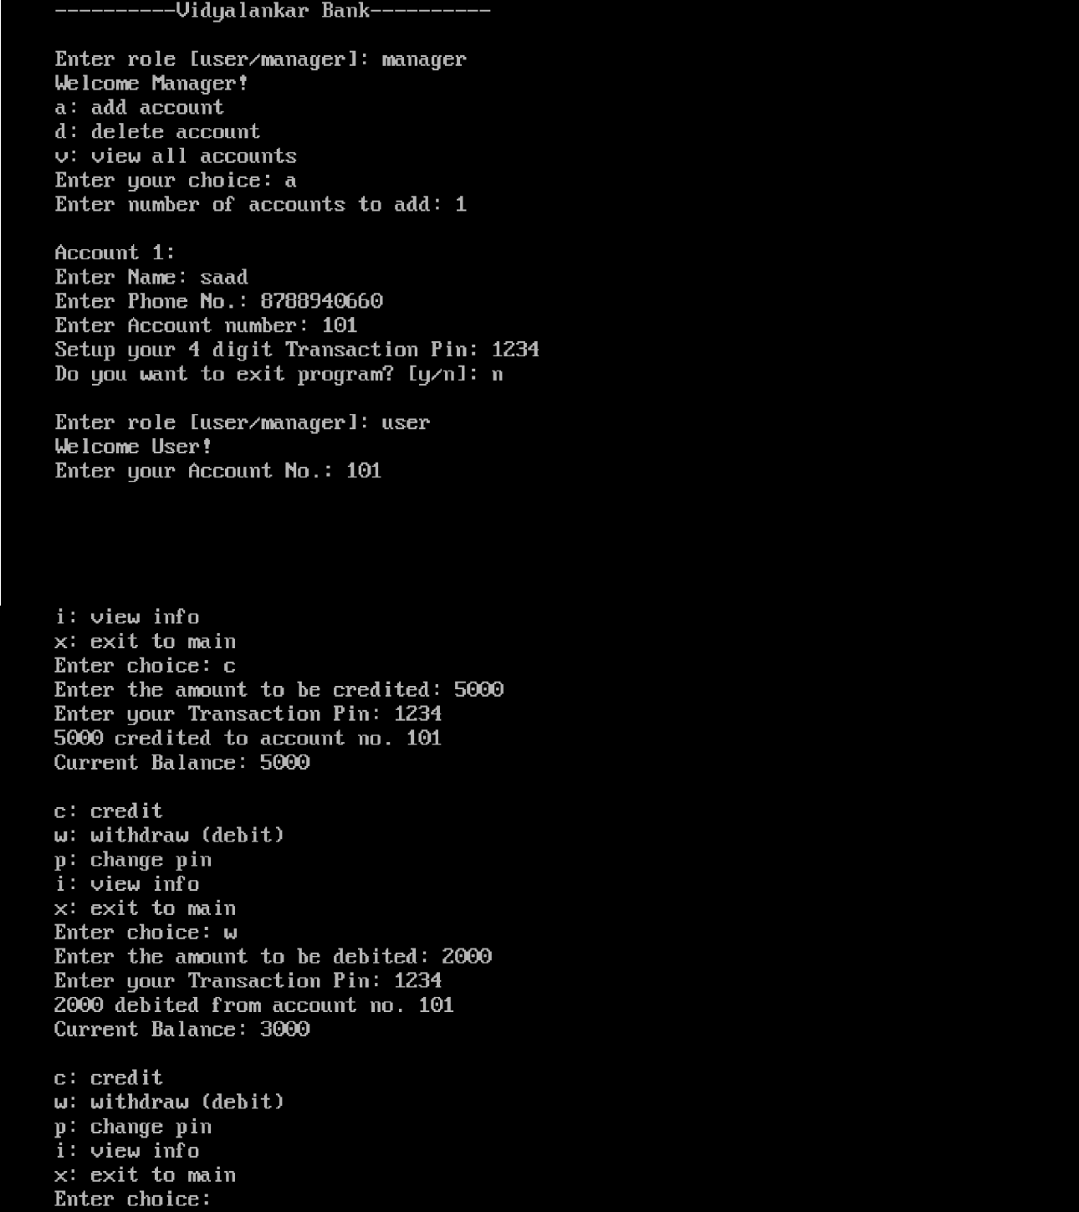


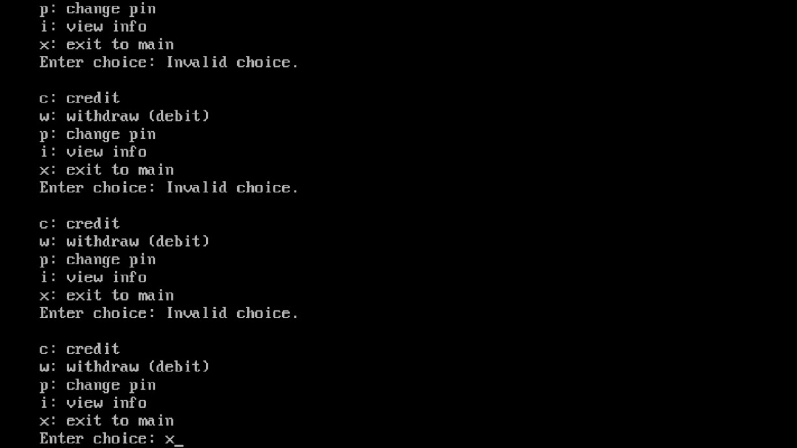


Group Members:

Group 2
Sr. No. | Name | Roll No.
1 | Mohd Saad Khan | 24203A0007
2 | Saad sharif kazi | 24203A0013
3 | Naman Pandey | 24203A0010
4 | Vaibhai badade | 24203A0014

Name of Programme: Computer Engineering

Semester: 3
Course Title: Object Oriented Programming Using C++
Code: 313302
Title of the Micro Project: Bank Management System using OOP in C++

Course Outcomes Achieved:

- Learned to apply OOP concepts such as classes, objects, constructors, and friend functions.
- Strengthened problem-solving skills through modular and menu-driven programming.
- Improved understanding of OOP concepts in practical real-life applications.


Micro Project Evaluation Sheet
Comments/Suggestions about team work/leadership/inter-personal communication (if any)

----------------------------------------------------------------------------------------------------------------------------

--------------------------------------------------------------------------------------------------------------------

Any other Comments:
-------------------------------------------------------------------------------------------------------------------------

-------------------------------------------------------------------------------------------------------------------------

